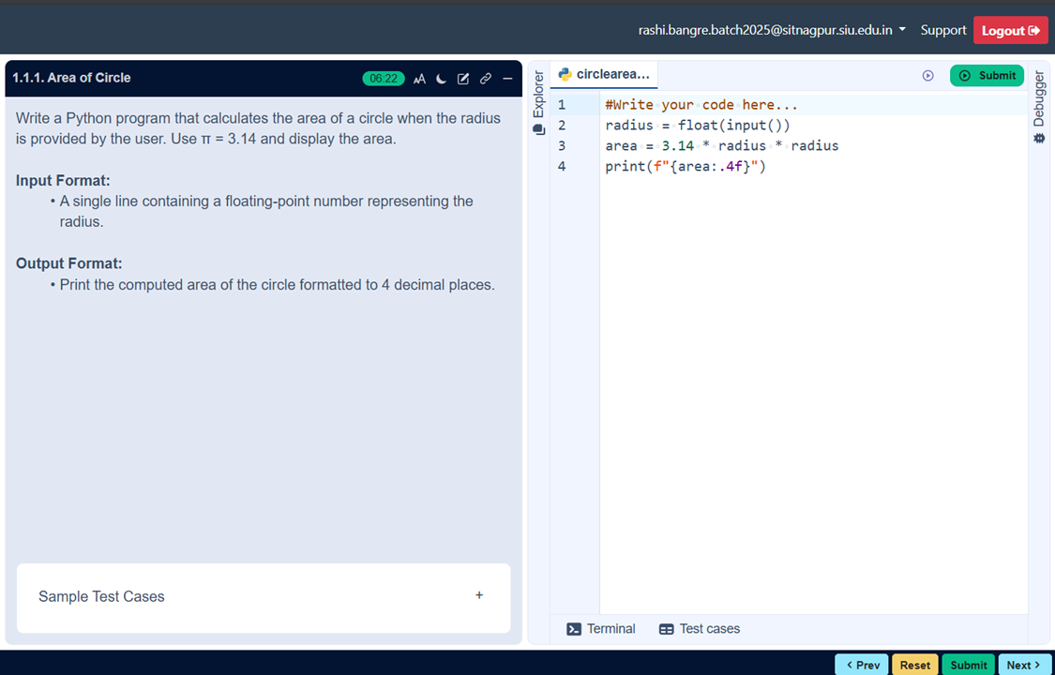
1.1.1 AREA OF CIRCLE
ALGORITHM
Step 1: Start
Step 2: Input radius
Step 3: Calculate
area=3.14*radius*radius
Step 4: Print area
Step 5: Stop

